HTML-CSS PRACTICE 05

1. Let’s create chart layout like the image bellow

Resource: “chat”

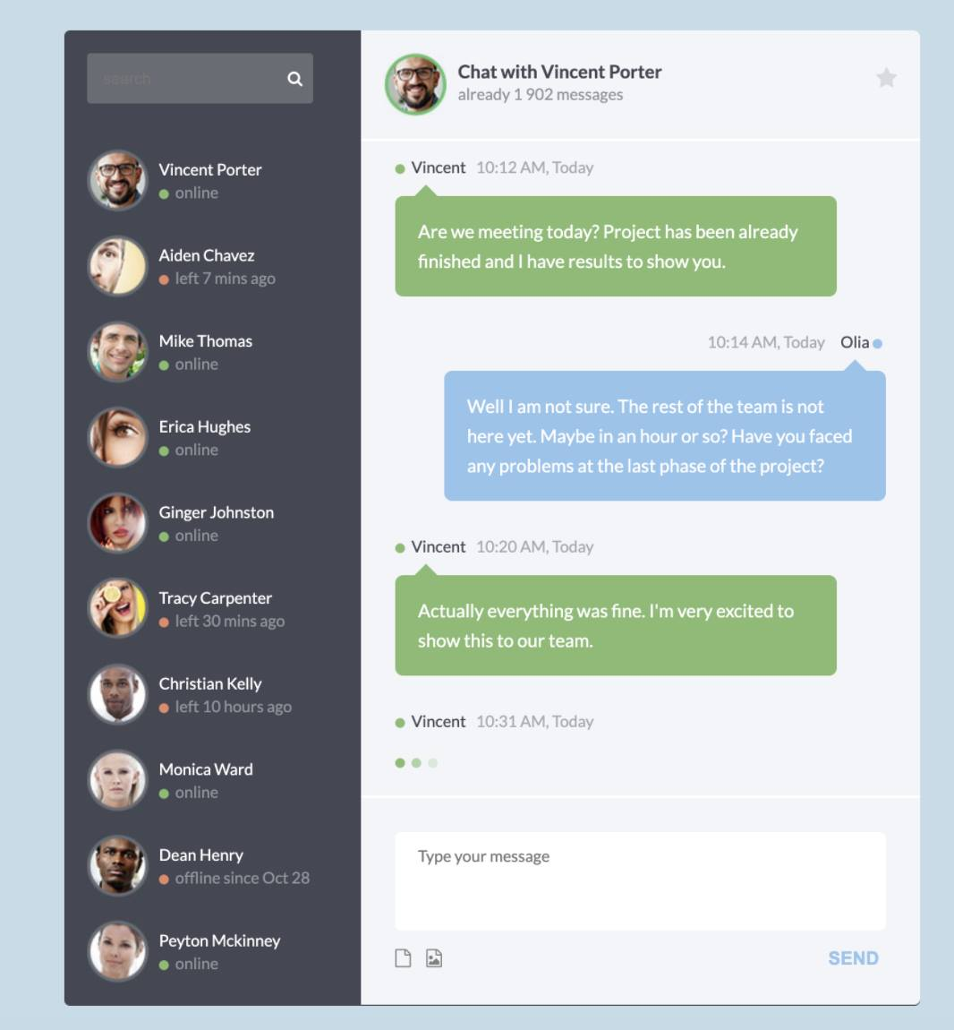

1. Let’s create single page like all images bellow

Resource: “layout”

- State 1: desktop version

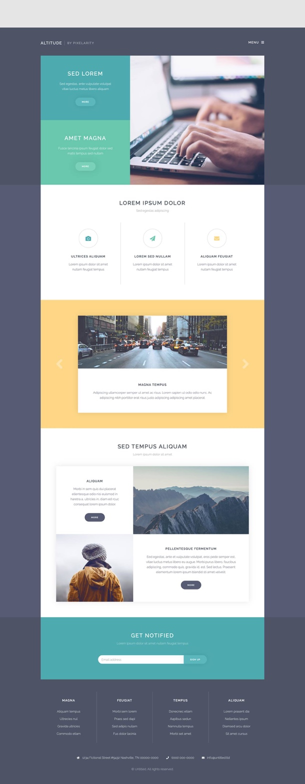

- State 2: mobile version



Note that: use the “bootstrap” is mandatory. You need to create at least 2 resource base on bs 3/4/5

1. Let’s create the grid like the image bellow

Resource: “grid”

